**Personal Journal**

**Daily status and reflection**:

* Day 1: Arrange team contract and look at the tasks ahead to decide who will be trying to achieve what individually.
* Day 2: Tasked with constructing context diagrams and high-level business models.
* Day 3: Tackled the stakeholder analysis and user roles which I built off the context diagram previously completed.
* Day 4: Tasked with documenting the non-functional requirements.
* Day 5: Outlining the security requirements and features in the design document.
* Day 6: Completed the UI design for the web app, with the web page wireframe sketches taking the most time.
* Day 7: Created the Django project. Pretty straightforward.
* Day 8: Tasked with creating the HTML foundation for the web app. Lengthy task.
* Day 9: Set up the database, created models, made migrations.

**Team Discussion and Decisions Entries:**

**Entry 1**: Discussion over HTML layout. Question: should we generate the HTML ourselves or look for pre-made templates on the internet? Decision: pre-made HTML layout chosen to save time for other important tasks. Contribution: searched for possible free HTML templates.

**Entry 2**: Discussion over page styling. Question: should we style the page ourselves or use pre-made designs? Decision: pre-made CSS styling chosen, with minor alterations to make our design unique. Contribution: searched for

**Entry 3**: Discussion over input fields in product order form. Question: what input fields should we provide to the user placing an order? Decision: Name, Email, Phone Number, Product, and Message. Contribution: suggestion of message text field. Future iterations of the web app need to facilitate communications between consumers and suppliers to improve product, create unique orders, and make the overall purchasing process slightly more personable.

**Code Review**

Code reviewed: HTML for navigation buttons. We wanted to create a way of displaying different buttons on the condition of whether the user was logged in or not. Change made: Inclusion of if statement. We weren’t aware this was possible, so we will be implementing this in the future.

**Team Process Evaluation**:

Entry 1: Communication over status of individual task completion. We were mostly punctual when notifying the other teammate over individual task completion. We could have been more immediate in communications though, which would have meant we could discuss the completed tasks and what to move on to next as soon as possible.

Entry 2: Communication over difficulty of assigned tasks. We managed to help each other out quite a bit when we found difficulty in our assigned tasks. We could have been more honest and communicative about troubles we were individually having, which may have meant we would overcome some issue faster than tackling it by ourselves.

**Reflective Journal**

**Technical Commentary**:

Personal contributions:

* Day 1: Arrange team contract and look at the tasks ahead to decide who will be trying to achieve what individually.
* Day 2: Tasked with constructing context diagrams and high-level business models.
* Day 3: Tackled the stakeholder analysis and user roles which I built off the context diagram previously completed.
* Day 4: Tasked with documenting the non-functional requirements.
* Day 5: Outlining the security requirements and features in the design document.
* Day 6: Completed the UI design for the web app, with the web page wireframe sketches taking the most time.
* Day 7: Created the Django project. Pretty straightforward.
* Day 8: Tasked with creating the HTML foundation for the web app. Lengthy task.
* Day 9: Set up the database, created models, made migrations.

Team role**:** equal partner. More familiar with Django than teammate, so I took control of setting up the project and creating web pages + connecting all the necessary parts.

Design discussions: mostly around the HTML and CSS of the web app. Aside from the deliberation on those topics, we were largely able to complete our assigned tasks individually.

**Design commentary:**

Discussion over input fields in product order form. Question: what input fields should we provide to the user placing an order? Decision: Name, Email, Phone Number, Product, and Message. Contribution: suggestion of message text field. Future iterations of the web app need to facilitate communications between consumers and suppliers to improve product, create unique orders, and make the overall purchasing process slightly more personable.

Reflection: even though it wasn’t necessary for the scope of the project, we felt including a message box was important for future communication-oriented iterations of the web app.

**Implementation commentary:**

One feature implementation that I contributed to was that of the login page from. The use of crispy forms was chosen for its clean aesthetic and straightforward HTML.

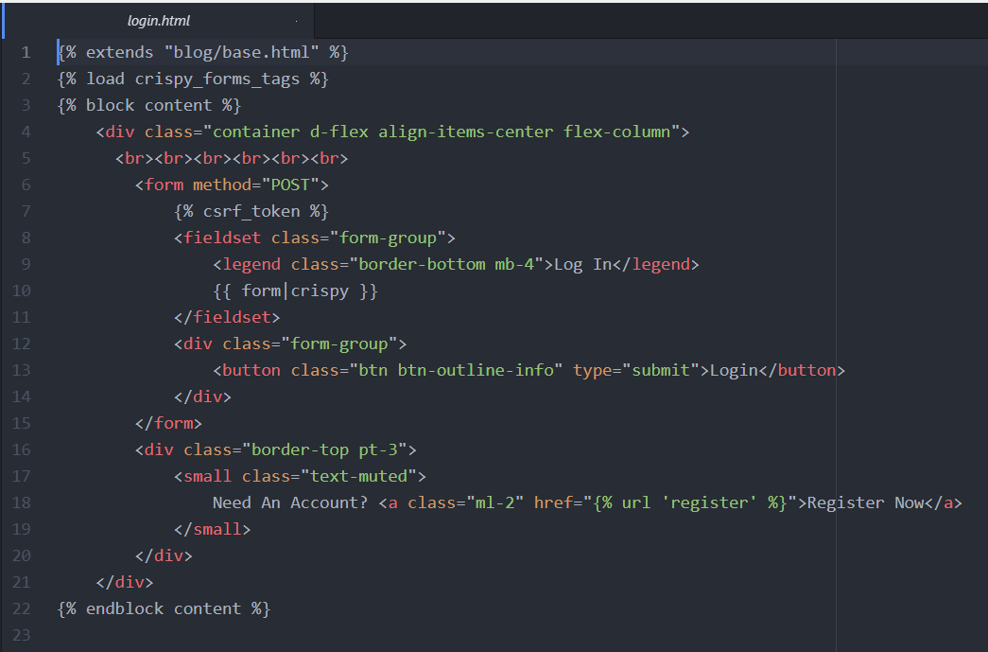

**Code review reflection:**

Code reviewed: HTML for navigation buttons. We wanted to create a way of displaying different buttons on the condition of whether the user was logged in or not.

Change made: Inclusion of if statement. A more straightforward fix than we had anticipated.

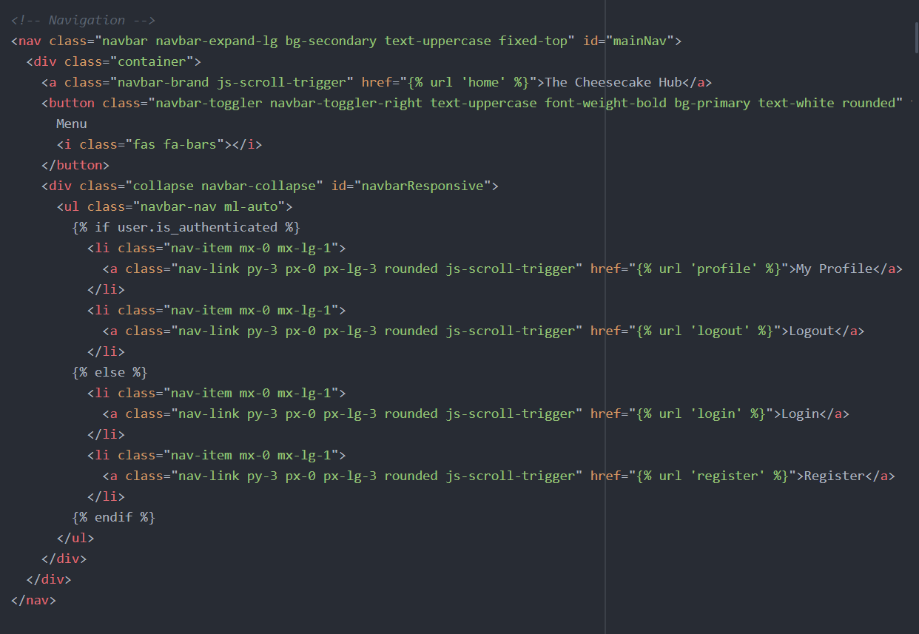

**Testing commentary:**

Test 3:

User story: As a registered user I want to be able to place a product order.

Test condition – If a user fills out a product order form with the required information, their order is submitted for processing and stored in the database.

Preconditions – User must be registered.

Input data – Required information for product order.

Expected result - Order is submitted for further processing.

Post-condition – Order is successfully submitted, and user is returned to the home page.

Reflection: Test went very well, aside from a minor issue of the user not being redirected to the home page after order completion. Simple piece of HTML added.

**Team Process Reflection**

**A reflection on the teamwork:**

What went well: Roughly sticking to the deadline of completing individually assigned tasks.

What issues were met and how they were resolved: Slight lack of communication between team members at some points. Increased communications (at least once a day).

What could be improved next time: Constant communication when necessary.

**A reflection on the development process:**

What went well: Even team member contribution in the development process.

What issues were met and how they were resolved: Difficulty figuring out issues for individual tasks. Improved communication so see if we could help one another instead of keeping quiet.

What could be improved next time: Improved communication over technical issues each team member is having.